Guide to simulating frequency using ANSYS HFSS

1. Open ANSYS Electronics desktop.
2. Insert HFSS design.
3. Change the solution type: HFSS > Solution Type > Eigenmode
4. Change units: Modeler > Units > [nm or um]. Sometimes if a design has features orders of magnitude smaller than the units, the simulation will fail. This can be solved by changing the units.
5. Import design. This can be done following steps 3-5 in the previous section. If you were drawing the area around your features, you may need to subtract the design from a sheet (insert a rectangle around your design), in order to simulate the design.
6. Identify your design as a conductor: Select your design in the menu. Right click > Add boundary > PerfE > Enter
7. Draw the wafer under your design. Change the height to the height of your wafer, and select the appropriate material.
8. Draw a vacuum box around your stack-up. Change the height to 2120um, and the z position to -860um.
9. Assign a boundary to the vacuum box to account for the boundary of the cap & lid when mounting the sample in the fridge. Select the box in the menu > Right click > Add boundary > PerfE > Enter
10. Add solution setup: Right click on “Analysis” in the project manager > “Add solution setup…”
    1. Set minimum frequency to something below what you expect (Ex. 1GHz)
    2. Set number of modes (I typically set this to one more than the number of resonators on the chip – this makes it easy to confirm that we are looking at the resonator mode and not the box mode)
    3. Maximum number of passes: 99 (or something stupidly high so that it doesn’t time-out)
    4. Maximum Delta frequency per pass: 1
    5. Number of converged passes (under “Options” tab): 3
11. Right click on Setup 1 > “Analyze”
12. After the simulation has converged, Right click on “Results” in the project manager window. Choose “Solution Data”.
13. To plot the first mode:
    1. Select the vacuum box (so that it is highlighted)
    2. Right click on “Field Overlays” in the project manager > Plot Fleids > Mag_E
    3. Choose “In Volume” > AllObjects > Done

This will plot the fields associated with the first mode. This is useful for identifying which mode belongs to the resonator and which belongs to the CPW or box (if they are close in frequency).

Guide to simulating Qc using ANSYS HFSS

1. Follow steps 1-9 from the previous section. Include the CPW and launchers in your design.
2. Add rectangles between the backs of the launchers and the ground plan (as shown below.)

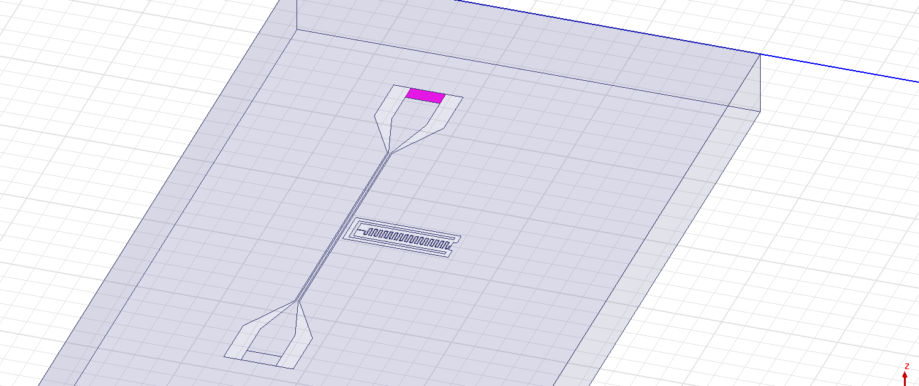

1. For each of these boxes: Right click > Assign boundary > Impedance…
   1. Resistance: 50 Ohm / square
   2. Reactance: 0 Ohm / square
2. Follow steps 10-13 from the previous section.